DATA SYSTEM ARCHITECTURE

MID TERM

311 CALL REPORT

NAME : KRITIKA VERMA

STUDENT ID : 200532320

CONTENT

INTRODUCTION

The 311 system serves as the primary contact centre for New York City's government, offering non-emergency services and information to its residents, businesses, and visitors. Its inception in 2003 aimed to provide a simplified and streamlined approach to accessing city services, and since then, it has become an essential resource for New Yorkers.

Residents can utilize the 311 system to report non-emergency issues, including noise complaints, hot water issues, parking problems, street light outages, and trash collection. Moreover, the system allows users to obtain information on various city services and programs.

The implementation of the 311 system has dramatically improved the quality of life in New York City by enhancing the government's efficiency and effectiveness. By simplifying access to city services, 311 has increased the convenience for residents to report issues and obtain information, leading to a more accessible and effective government.

OBJECTIVE

The New York City 311 system's primary objective is to provide a centralized location for residents to obtain non-emergency services and information from the local government.

The system intends to simplify and streamline the process of reporting non-emergency issues, requesting assistance, and accessing information on local programs and services for citizens, companies, and visitors.

By offering a single point of contact for non-emergency services and information, the 311 system aims to increase the efficiency and effectiveness of city services, promote accountability, encourage citizen participation with the local government, and improve transparency.

Ultimately, the 311 system's goal is to enhance the quality of life for New York City residents by providing timely and efficient services and information.

ANALYSIS

Analysis of the data collected through the New York City 311 system can provide valuable insights. Here are some potential observations and analyses based on the data:

TOP COMPLAINTS :

The table presents data on the most frequent complaint types logged through the 311 service requests system. The most common complaint type is noise, particularly noise from residential areas, with a total of 55,850 rows. Following that is street condition, with 25,986 rows, and street light condition, with 24,163 rows. Unsatisfactory conditions, such as unsanitary conditions, are the fourth most common complaint type with 20,905 rows, followed closely by water system issues with 18,339 rows. Blocked driveway complaints are also quite common, with 18,127 rows, and PAINT/PLASTER issues rank seventh with 18,032 rows. Illegal parking is the eighth most common complaint with 16,139 rows, and noise on the street/sidewalk is the ninth most frequent complaint type with 16,099 rows. The final complaint type in the table is general construction/plumbing, with 13,235 rows. This information could be helpful to city officials in identifying problem areas that need to be addressed to improve quality of life for residents.

GEOGRAPHIC DISTRIBUTION :

The data presented below shows the number of 311 service requests made in each of New York City's boroughs. The borough with the highest number of 311 service requests is Brooklyn, with a total of 166,534 requests. Queens has the second-highest number of requests with 130,472. Manhattan follows Queens with 105,888 service requests. The Bronx has a lower number of service requests compared to the top three, with 88,565 requests. Staten Island has the lowest number of 311 service requests, with just 29,031. Lastly, there are 9,554 requests marked as unspecified. These numbers indicate that Brooklyn has the highest number of issues that the residents of the borough need help with, while Staten Island has the lowest number of reported issues. It will be important for officials to look into the underlying reasons for the discrepancies in order to ensure equitable distribution of resources and address the concerns of all residents of the city.

WAY OF CONTACT:

The data provided above shows the various methods used to report crimes in New York City. The most common method of reporting crime is through the phone, with 14,810,577 reports made through this method. The second-most common method is online, with 7,009,336 reports filed through the internet. The data also shows that a significant number of crime reports are marked as unknown, with 6,269,031 reports falling under this category. The mobile app is also used as a method of reporting crime, with 3,110,256 reports submitted through it. Lastly, 368,059 reports are classified as 'Other,' which indicates that there are various other methods of reporting crimes used by the citizens of New York City. It is essential to note that this data is useful for officials to identify the most commonly used methods of reporting crime. By analysing the data and identifying patterns in reporting, authorities can enhance response time and improve overall safety in the city.

RESPONSE TIME :

The graph provided above shows various New York City agencies arranged in descending order of their response times. At the top of the graph is the New York City Police Department, which has the lowest response time. Following the NYPD is the Department of Housing Preservation and Development, which also has a relatively low response time. The Department of Transportation has the third-lowest response time on the list, followed by the Department of Sanitation and the Department of Environmental Protection, respectively. The Department of Parks and Recreation has a slightly higher response time than the previous agencies, with the Department of Buildings and the Department of Health and Mental Hygiene following closely behind. The Department of Consumer Affairs and the Taxi and Limousine Commission have the slowest response times on the graph, indicating that they may need to improve their operations to address concerns more efficiently. The order of agencies provides useful information for identifying areas where there may be bottlenecks in the system and taking corrective measures to enhance service delivery.

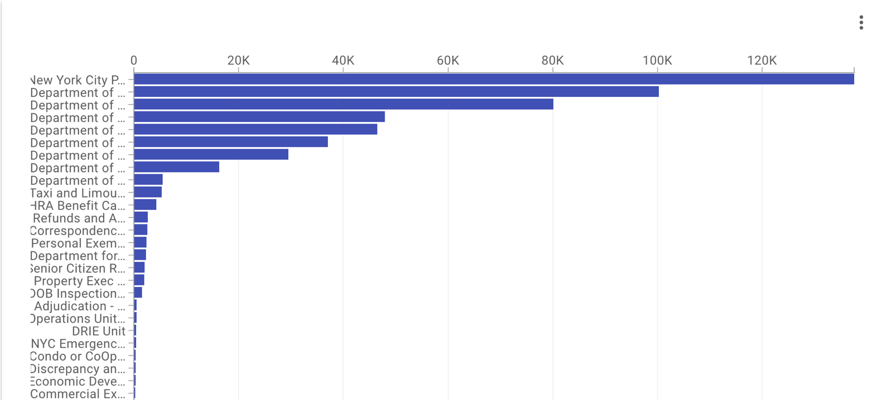

CONCLUSION

After analysing the various data sets provided, it is evident that there are numerous factors that impact the quality of life for citizens of New York City. These factors include issues such as noise pollution, street conditions, unsanitary conditions, and parking violations. The New York City Government has numerous agencies in place to address these issues, ranging from the New York City Police Department to the Department of Consumer Affairs. By analysing the data and identifying areas where the system may have bottlenecks, the government can work towards improving the efficiency of the response system and enhancing the overall quality of life for citizens.

One of the most notable pieces of data presented was the number of 311 calls made to report residential noise. According to the data, there were 55,850 calls made to report this issue, making it the most commonly reported issue in the city. This highlights the impact of noise pollution on citizens and emphasizes the need for effective measures to address the problem. Additionally, street conditions were the second most commonly reported issue, with 25,986 reports. This highlights the need for continuous maintenance of infrastructure and effective measures to address the issue.

The data on the response times of different agencies was also enlightening. The New York City Police Department had the lowest response time, followed by the Department of Housing Preservation and Development and the Department of Transportation. The data indicates that some agencies may need to improve their operations to enhance the efficiency of the response system and address concerns more effectively. The order of agencies provides useful insights into areas that need to be improved and could aid in developing more effective policies to address concerns.

Another notable piece of data provided was the different methods used to report crimes. The phone was the most commonly used method, with online being the second-most used. The data also indicated that a significant number of reports were classified as unknown, highlighting the need for better tracking and monitoring systems. This data could be used to improve the efficiency of the response system and enhance overall safety in the city.

In conclusion, the data provided offers useful insights into the quality of life of citizens in New York City. The data highlights the need for continuous maintenance of infrastructure, effective measures to address noise pollution and other issues, and efficient response systems to address concerns effectively. By analysing the data and identifying areas that need to be improved, the government can work towards enhancing the overall quality of life for citizens and making New York City a safer and more liveable place.

RECOMMENDATION

After analysing the various data sets provided, it is evident that there are areas where the response system in New York City needs to be improved. While the city government has numerous agencies in place to address issues such as noise pollution and street conditions, there are still challenges that need to be addressed. In this report, we present recommendations for how the city government can enhance the efficiency of the response system and improve the overall quality of life for citizens.

One of the key issues that need to be addressed is the response time of different agencies. While some agencies, such as the New York City Police Department, have relatively low response times, others have longer response times. The Department of Environmental Protection and Department of Health and Mental Hygiene had the longest response times, which is unacceptable given the nature of the issues they handle. We recommend that these agencies work to improve their response times by identifying bottlenecks in their operations and streamlining their processes.

Another area that requires improvement is the tracking and monitoring of crime reports. According to the data, a significant number of reports were classified as unknown. This indicates that the city government needs to implement better tracking and monitoring systems to ensure that all reports are accounted for and addressed. We recommend that the city government work with agencies to develop more efficient tracking and monitoring systems that can capture all reports and help agencies respond more effectively.

Additionally, the data on the different methods used to report crimes is also notable. The phone was the most commonly used method, followed by online. This indicates that the city government needs to ensure that their online reporting system is efficient and user-friendly. We recommend that the city government work to enhance their online reporting system and promote its use to citizens to encourage more people to report issues online.

Furthermore, it is crucial to address the issue of noise pollution in the city. According to the data, residential noise was the most commonly reported issue, indicating the need for effective measures to address the problem. We recommend that the city government works towards implementing a comprehensive noise pollution management plan that includes effective regulations and policies to reduce noise pollution in the city.

In conclusion, while the data provided offers useful insights into the quality of life of citizens in New York City, there are still areas where the response system needs to be improved. By implementing the recommendations we have presented, the city government can enhance the efficiency of the response system, improve the tracking and monitoring of reports, promote online reporting, and address the issue of noise pollution more effectively. These improvements will help make New York City a safer, more liveable place for all citizens.

APPENDIX